This language has a large vowel inventory, since vowels travel better underwater. The consonants are mostly fricatives and aspirated stops. There are also clicks, which aren’t that common in modern languages, because these are heard well underwater and are similar to sounds that marine animals make to communicate. (sound inventory largely inspired by animal sounds, esp. whales and dolphins)

Allowed Vowels:
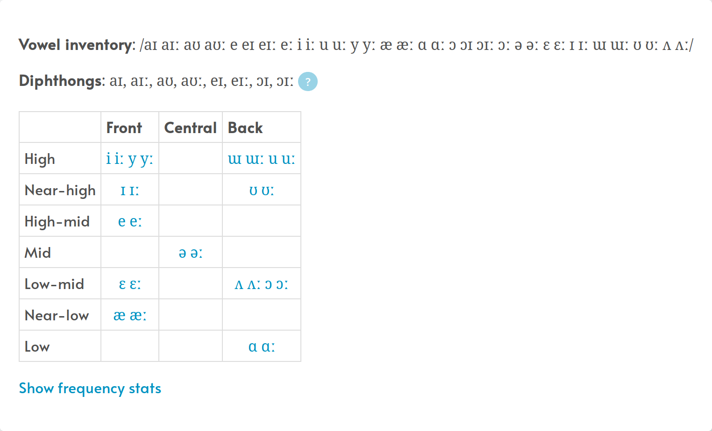

Allowed Consonants:
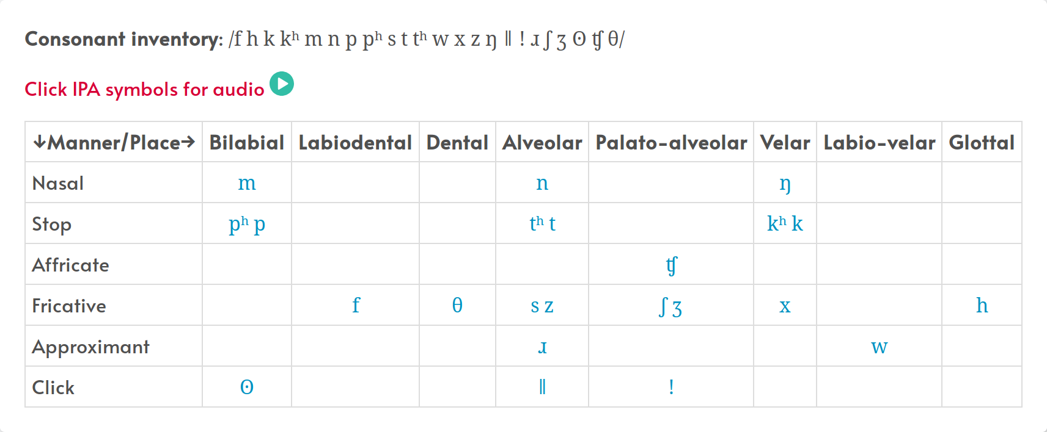
Consonant clusters:
- Word-initial: f,h, m, n, s, sn, sm, sɹ, sf, l, ɹ, hɹ, lɹ, sl,ml, w, wr, wl, fl, ŋ, ŋh, ǁ, ǃ, ɹ, ʃ, ʃɹ, ʃf, ʃl, ʘ, θ, ʒ, ʒl, zl, lz, ʒh, ʒm, ʒn
- Mid-word: f, h, m, n, ŋ, ɹ, s, ʃ, w, wɹ , θ, wh, ʒ, z
- Word-final: f,h, m, n, s, sn, sm, sɹ, sf, l, ɹ, hɹ, lɹ, sl,ml, w, wr, wl, fl, ŋ, ŋh, ǁ, ǃ, ɹ, ʃ, ʃɹ, ʃf, ʃl, ʘ, θ, st^{h}, lt^{h}, mt^{h}, nt^{h}, ft^{h}, ht^{h}, ŋt^{h}, ɹt^{h}, sp^{h}, lp^{h}, mp^{h}, np^{h}, fp^{h}, hp^{h}, ŋp^{h}, ɹp^{h}, sk^{h}, lk^{h}, mk^{h}, nk^{h}, fk^{h}, hk^{h}, ŋk^{h}, ɹk^{h}, ms, ns, hs, fs, ɹs, ls, wt^{h}, wk^{h}, wp^{p}, wθ, sθ, rθ, nθ, mθ, fθ, θt^{h}, θp^{h}, θk^{h}, mh, nh, sh, fh, ʒ, sʒ, ʒm, ʒn, ʒf, ʒh
Not allowed: stop + Consonant (anywhere), stop word initial (or syllable initial)

Syllabic structures:
(C_{[-stop]})(C_{[-stop]})V
V(C_{[-stop]})(C)
C_{[click]}
VVV*
V(C_{[-stop]})V
- syllables must have a vowel (except for click-only syllables)

- aspirated stops must be word-final (otherwise changed to nasal of same place)

